**Date: 2020. 04. 09 [201533661 이승수’s Data Structure Lab2-2]**

**[Lab2-2]**

**What Are the Results of#1 level order, #2 Postorder, #3 Preorder Traversal? (9 points)**

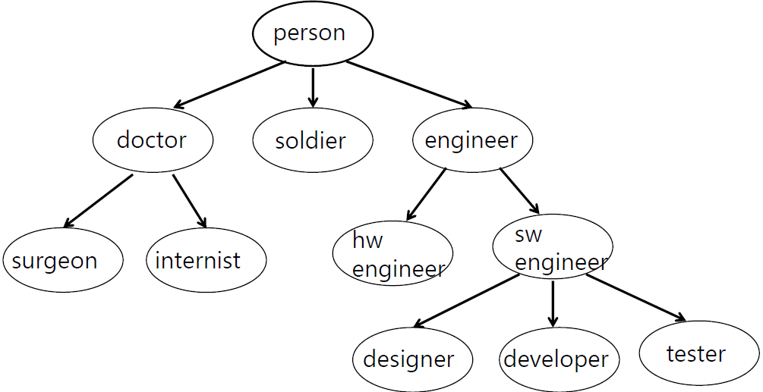

**Result)**

**#1 Level Order Traversal**

person -> doctor -> soldier -> engineer -> surgeon -> internist -> hw engineer -> sw engineer

-> designer -> developer -> tester

**#2 Post-Order Traversal**

surgeon -> internist -> doctor -> soldier -> hw engineer -> designer -> developer -> tester ->

sw engineer -> engineer -> person

**#3 Pre-Order Traversal**

person -> doctor -> surgeon -> internist -> soldier -> engineer -> hw engineer -> sw engineer

-> designer -> developer -> tester